Direct Connect Bandwidth Upgrade request template
Cloud: AWS
TAO Region: <Networksitecode>
Cloud Region: ap-southeast-1
AWS Account ID: 185132999849
ASN TAO: <ASN> WAN Team to provide
ASN AWS Side DX GW: 65350
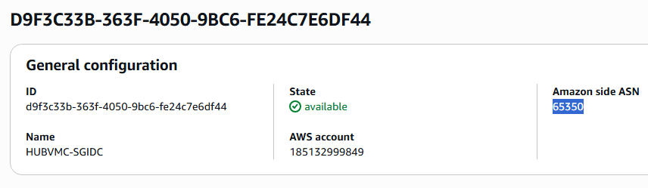
ASN Transit GW: 65351
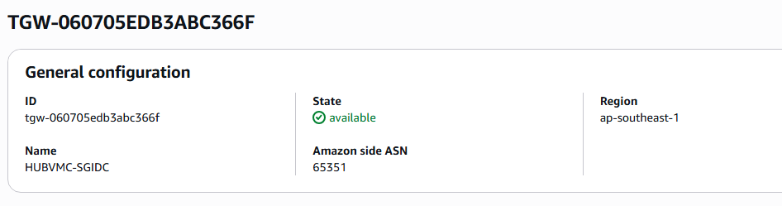
B/W: 200 MBPS
Primary Connection - <Name> AT&T/WAN to align
Destination VLAN Tagging <ID> - ATT To provide, after submitting MACD
ASSA-SG1-AWS-PRI-01
IP: 10.254.21.1/30 -- TAO (Currently reserved in AWS)
IP:10.254.21.2/30 -- AWS -- (Currently reserved in AWS)
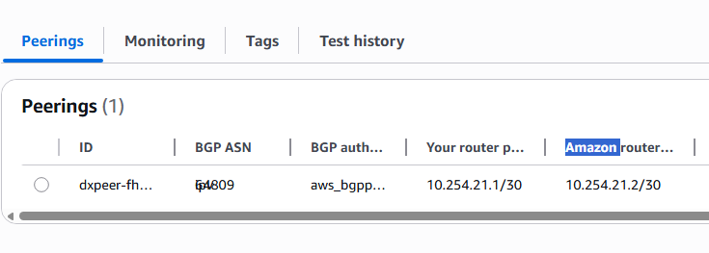
ASSA-SG4-AWS-SEC-01
IP: 10.254.21.5/30 -- TAO (Currently reserved in AWS)
IP:10.254.21.6/30 -- AWS -- (Currently reserved in AWS)
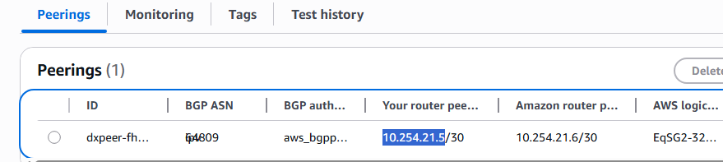

Router Filter:
Allow in (from AWS)
10.0.0.0/8 & 100.96.0.0/12

Allow out (to AWS)
AWS advertises the following over the BGP ('Allowed Prefixes' List on the Direct Connect Gateway):
• 10.29.0.0/28 • 10.29.0.32/28 • 10.29.0.80/28 • 10.29.0.96/28 • 10.29.0.112/28 • 10.29.0.176/28 • 10.29.0.180/32 • 10.29.0.224/28 • 10.29.1.64/28 • 10.29.1.160/28 • 10.29.1.176/28 • 10.29.50.0/24 • 10.29.192.0/20 • 10.29.224.128/29
Change Activities performed:
